LC#2 ADD TWO NUMBERS IN THE LINKEDLIST IN THE REVERSED ORDER 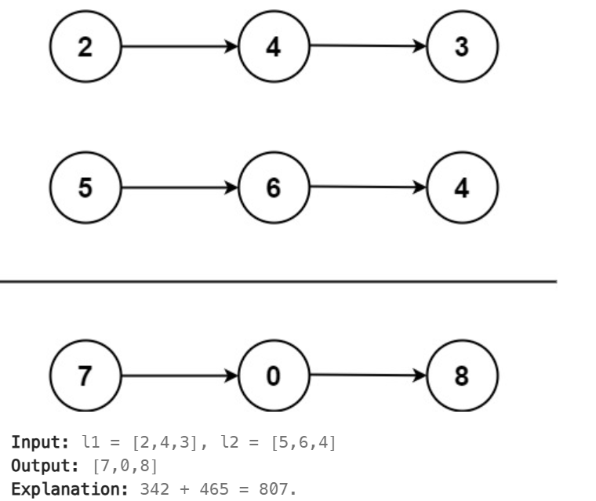
APPROACH:
->create a dummy node and a traversing pointer for it
-> take sep variables for clarity if any node is null assign 0
->edge case carry check

class Solution {
public ListNode addTwoNumbers(ListNode l1, ListNode l2) {
ListNode dummy = new ListNode(0);//-1 also works
ListNode head = dummy;
int carry = 0;
while(l1!=null ||l2!=null )
{
int a = l1!=null?l1.val:0;
int b = l2!=null?l2.val:0;
int sum = a+b+carry;
int dig = sum%10;
carry = sum/10;
head.next= new ListNode(dig);
head = head.next;
if(l1!=null)
l1=l1.next;
if(l2!=null)
l2 = l2.next;

}
if(carry!=0)
head.next = new ListNode(carry);
return dummy.next;
}
}

LC#369 ADD ONE LINKEDLIST LEETCODE PREMIUM BUT GFG AVAILABLE
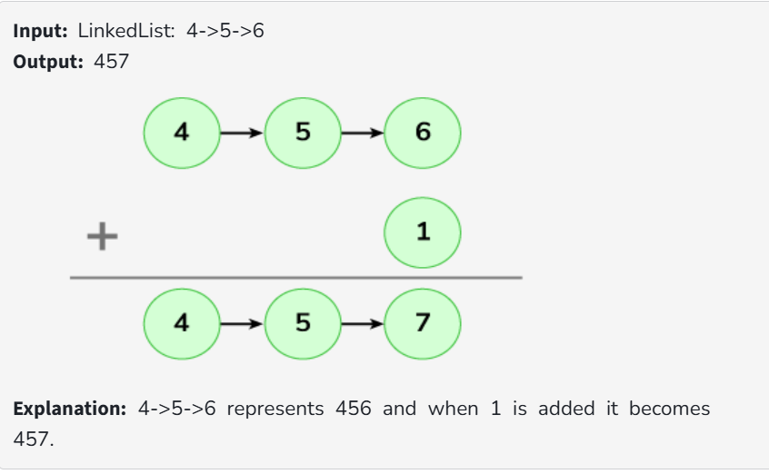

If all 9999 means it will become
1>9>9>9>9=>1>0>0>0>0

class Solution {
public Node addOne(Node head) {
// dummy node to simplify operations
Node dummy = new Node(0);
dummy.next = head;

Node lastNonNine = dummy;
Node curr = head;

// 1. Find rightmost non-9 node
while (curr != null) {
if (curr.data != 9)
lastNonNine = curr;
curr = curr.next;
}

// 2. Increase that node by 1
lastNonNine.data++;

// 3. Set all nodes after it to 0
curr = lastNonNine.next;
while (curr != null) {
curr.data = 0;
curr = curr.next;

// 4. If dummy was incremented from 0 to 1, return dummy, else dummy.next
return dummy.data == 1 ? dummy : dummy.next;
}}

